NEUROSURGERY ONE NEW PATIENT PAPERWORK

Name: ______________________________________
DOB: _______________________________________
Today’s Date:_________________________________

Sex: (circle) M F Preferred pronouns: _________________
Preferred Language: _____________________
Would you prefer to speak to your healthcare provider through a Translator? Yes No

Mailing address: ____________________________________________________________________________________
__________________________________________________________________________________________________
Home phone: ________________________________ Cell Phone: ____________________________________________
Email: ____________________________________________________________________________________________

Referring Provider:_________________________________ Phone Number: _________________________________
Primary Care Provider: ______________________________ Phone Number: _________________________________
Reason for your visit (chief complaint: _________________________________________________________________
My main goal(s) for my visit today (check all that apply)

- First opinion
- Second opinion
- Recommendation for Physical Therapy
- Injection/Conservative Therapy/Treatment
- Surgery

- Other ______________________________________________________________________________________
Onset of current symptoms: (circle)
Acute injury Gradual over time Worker’s-compensation Motor vehicle accident
Other: ____________________
Describe your current symptoms:
- Location (where on your body) _________________________________________________________________
- Quality (words to describe pain) ________________________________________________________________
- Approximate date of symptom onset: ____________________________________________________________
- Duration (how long have you been experiencing the pain?) _________________________________________
- Timing (constant, intermittent, with position change, activity, etc)____________________________________
- Does anything make the pain better? ___________________________________________________________
- Does anything make the pain worse? (lifting, coughing, standing, laying down, etc) ___________________________________________________________________________________________
- Progression: (circle) Worsening Unchanging Improving Changing –_______________________
- Associated symptoms (circle) Numbness Tingling/Pins and Needles Weakness
Other, explain: ________________________________________________________________________
- Do you use any assistive devices to help with ambulating?
No Cane Walker Wheelchair Motorized Scooter Other:_____________
- Is there litigation surrounding the case? (circle) Yes No
  - If yes, Attorney’s name: ________________________________________________________________
Indicate the current severity of your pain by circling a number below:
0 | 1 | 2 | 3 | 4 | 5 | 6 | 7 | 8 | 9 | 10
Please use the illustration below to shade affected areas:
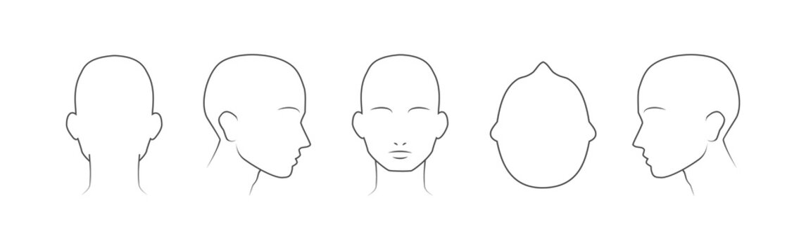
Indicate what treatments you have already tried for your current problem: (check any that apply)

- No treatment
- Physical Therapy
- Trigger Point Injections
- Epidurals/Nerve Blocks
- Chiropractor/Chiropractic Treatment
- Physiatrist
- Massage or Ultrasound
- Dry Needling
- Acupuncture
- Yoga/Pilates
- NSADS (medication management)
- TENS Unit
- Surgery

- Other treatments: __________________________________________________________________________

What diagnostic test have you had performed for this problem? (check all that apply)

- X-RAYS
- MRI
- CT/CAT SCAN
- EMG/NERVE CONDUCTION STUDY
- OTHER: ______________________________

Please provide your care team, if applicable:

- Neurology ________________________
- Neurosurgery_____________________
- Endocrinology_____________________
- Physiatry_________________________
- ENT/Otolaryngology________________

- Other:_____________________________________________________________________________

If recommended, please rate how interested you are in having surgery to treat your problem:
0 | 1 | 2 | 3 | 4 | 5 | 6 | 7 | 8 | 9 | 10
Not at all Maybe Definitely

PATIENT HISTORY
Current Medications: include prescriptions, over the counter medications, vitamins and supplements. Note: Please include as-needed medications as well.
______________________________________________________________________________________________________________________________________________________________________________________________________________________________________________________________________________________________________
Preferred Pharmacy: ________________________________________________________________________________
Allergies:
- No known drug allergies
- Known allergies include (please include drug and reaction) ______________________________________________________________________________________________________________________________________________________________________________________

Medical History: check any medical problems you have been treated for.

- Alcoholism
- Anemia
- Arrhythmia (irregular heart beat)
- Arthritis
- Asthma
- Atrial fibrillation
- Bronchitis
- Coronary Artery/Heart Disease
- Cancer (Type___________)
- Cardiovascular Disease
- Congestive Heart Failure
- Crohn’s Disease
- Cirrhosis
- Colitis
- Constipation
- COPD (lung disease)
- Chronic Renal Failure
- CVA (stroke/brain hemorrhage)
- Dementia/Alzheimer’s
- Degenerative Disc Disease
- Degenerative Joint Disease
- Diabetes, Type I
- Diabetes, Type II
- Emphysema
- Epilepsy
- Fracture
- GERD
- Glaucoma
- Hepatitis
- High Cholesterol
- Hyperlipidemia
- Implanted Medical Device
- Kidney Disease
- Ulcers
- Liver Disease
- Migraine
- Multiple Sclerosis
- Nephrolithiasis (Kidney Stones)
- Obesity
- Osteoarthritis
- Osteoporosis
- Prior MI (Heart Attack)
- Pulmonary Disease
- RA (Rheumatoid Arthritis)
- Seizures
- Sickle Cell Disease
- Sexually Transmitted Disease
- Thyroid Disease
- TIA (mini-stroke)
- Tuberculosis
- Tumor
- Valve Problem
If YES to osteoporosis or osteopenia, date of last DEXA/Bone Density Scan: __________________________
Other medical history: _______________________________________________________________________

Surgical History: include approximate date for listed surgeries

- No prior surgeries
- Appendectomy
- D&C
- Hysterectomy
- Knee arthroscopy
- Mastectomy
- Shoulder surgery
- Spinal surgery
- Tonsillectomy
- Total knee replacement
- Total hip replacement
- Tubal ligation

- Other: ______________________________________________________________________________
If YES to previous spinal surgery, please explain: _________________________________________________

Family History: indicate if family members have pertinent medical problems (M=Mother, F=Father, S=Sibling)

___Ankylosing Spondylitis
___Arthritis
___Alcoholism
___Anxiety
___Asthma
___Bleeding Disorder
___CAD (Heart Disease)
___MI (Heart Attack)
___Cancer
___Colitis
___COPD
___Crohn’s Disease
___CVA/TIA (stroke)
___Depression
___Diabetes
___Epilepsy
___GERD
___Gout
___Hypertension
___Kidney Disease
___Liver Disease
___Osteoarthritis
___Osteoporosis
___Psoriasis
___Pulmonary Disease
___Renal Disease
___RA (Rheumatoid Arthritis)
___SLE (Lupus)
___Substance Abuse
___Thyroid Condition
___Tumor
___Other: _________________

SOCIAL HISTORY
Tobacco (circle) Never smoker Current every day smoker Current some day smoker Former smoker – Year quit_________, Years smoked_________
E-Cigarette/Vaping (circle) Every day user Some day user Former user Never User
Alcohol (circle) Yes Not currently Never Defer
Illicit Drug Use: Yes Not currently Never Defer
Marijuana Use Yes Not currently Never Defer
Marital Status: (circle) Single Life Partner Married Divorced Separated Widowed Defer
Diet: (circle all that apply) Well balanced Diabetic Vegetarian Vitamins/Herbs
With whom do you live? Alone Children Spouse/partner Parents Assisted Living _____________
Safety:

- CO Detector in Home
- Seat Belt Use
- Water Heater Temp Set
- Guns Unloaded/Locked
- Smoke Detector in Home

- Helmet Use
- Sunscreen Use

Race:

- American Indian or Alaskan Native
- Black or African American
- Native Hawaiian or other Pacific Islander
- Asian
- White
- Other ______________________
- Decline

Religion: __________________________________________________________________________________________
Ethnicity: Do you consider yourself to be Hispanic or Latino? Yes No Decline
Preventative Care: Last complete physical exam with your primary care provider ______________________________
Occupation: (circle below) ____________________________________________________________________________
Work full-time Work part-time Unemployed On Disability
Retired Student

Patient Signature: __________________________________________________________ Date: ________________

